MATH Questions

- Show work/explanation where indicated.

1. (4 pts) Which of these graphs represent a one-to-one function? Answer(s): ____________
(no explanation required.) (There may be more than one graph that qualifies.)

(A)  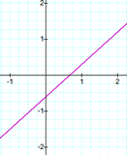 | (B)  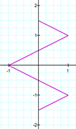 | (C)  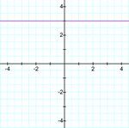 | (D)  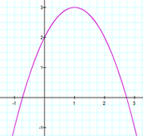

2. (6 pts) Students in a math class took a final exam (with a grade scale of 0 to 100) and then took equivalent forms of the exam at monthly intervals thereafter. The average grade g after t months was found to be given by the function g(t) = 78 − 6.5 ln(t + 1), t ≥ 0.
(Note that "ln" refers to the natural log function) (explanation optional)
Using the model,
(a) What was the average grade when the students initially took the exam, when t = 0?

(b) What was the average grade on the exam when taken 3 months later, to the nearest integer?

3. (4 pts) Convert to a logarithmic equation: 6^{x} = 1296. (no explanation required) 2. ______

A. $\log_{6}{x}=1296$

B. $\log_{x}{6}=1296$

C. $\log_{6}{1296}=x$

D. $\log_{x}{1296}=6$

4. (8 pts) Solve the equation. Check all proposed solutions. Show work in solving and in checking, and state your final conclusion.

$\sqrt{13-x}=1-x$

5. (8 pts)
(a) $\log_{8}{1=}$_______ (fill in the blank)

(b) Let ${x=log}_{8}{\frac{1}{512}}$ State the exponential form of the equation.

(c) Determine the numerical value of $\log_{8}{\frac{1}{512}}$, in simplest form. Work optional.

6. (10 pts) Let f (x) = 3x² – 5x + 7 and g(x) = 1 – 4x

(a) Find the composite function $\left(f o g\right)\left(x\right)$ and simplify the results. Show work.

(b) Find $\left(f o g\right)\left(-1\right)$. Show work.

7. (16 pts) Let $f\left(x\right)=\frac{4x - 5}{2x + 1}$

(a) Find f ⁻ ¹ , the inverse function of f. Show work.

(b) What is the domain of f ? What is the domain of the inverse function?

(c) What is f (3) ? f (3) = ______ work/explanation optional

(d) What is f ⁻ ¹ ( ____ ), where the number in the blank is your answer from part (c)? work/explanation optional

8. (18 pts) Let f(x) = e ^{– x} + 3.

Answers can be stated without additional work/explanation.

(a) Which describes how the graph of f can be obtained from the graph of y = e^{x} ? Choice: ________

A. Reflect the graph of y = e ^{x} across the x-axis and shift upward by 3 units.
B. Reflect the graph of y = e ^{x} across the y-axis and shift upward by 3 units.
C. Shift the graph of y = e ^{x} to the right by 1 unit and shift upward by 3 units.
D. Shift the graph of y = e ^{x} to the left by 1 unit and shift upward by 3 units.

(b) What is the y-intercept?

(c) What is the domain of f ?

(d) What is the range of f ?

(e) What is the horizontal asymptote?

(f) Which is the graph of f ?

GRAPH A GRAPH B GRAPH C 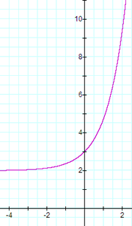 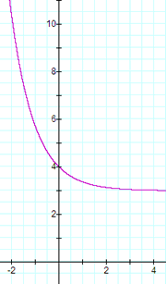 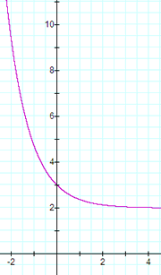

NONLINEAR MODELS - For the latter part of the quiz, we will explore some nonlinear models.

9. (18 pts) QUADRATIC REGRESSION

Data: On a particular summer day, the outdoor temperature was recorded at 8 times of the day. The parabola of best fit was determined using the data.

Quadratic Polynomial of Best Fit:
y = −0.24t² + 6.84t + 47.6 for 0 ≤ t ≤ 24 where t = time of day (in hours)
and y = temperature (in degrees)

REMARKS: The times are the hours since midnight.
For instance, t = 6 means 6 am. t = 22 means 10 pm. t = 18.25 hours means 6:15 pm

(a) Use the quadratic polynomial to estimate the outdoor temperature at 8:00 pm, to the nearest tenth of a degree. (work optional)

(b) Using algebraic techniques we have learned, find the maximum temperature predicted by the quadratic model and find the time when it occurred. Report the time to the nearest quarter hour (i.e., __:00 or __:15 or __:30 or __:45). (For instance, a time of 18.25 hours is reported as 6:15 pm.) Report the maximum temperature to the nearest tenth of a degree. Show algebraic work.

(c) Use the quadratic polynomial y = −0.24t² + 6.84t + 47.6 together with algebra to estimate the time(s) of day when the outdoor temperature y was 80 degrees.
That is, solve the quadratic equation 80 = −0.24t² + 6.84t + 47.6.

Show algebraic work in solving. Round the results to the nearest tenth. Write a concluding sentence to report the time(s) to the nearest quarter-hour, in the usual time notation. (Use more paper if needed)

10. (8 pts) + (extra credit at the end) EXPONENTIAL REGRESSION
Data: A cup of hot coffee was placed in a room maintained at a constant temperature of 66 degrees, and the coffee temperature was recorded periodically, in Table 1.

TABLE 1 | REMARKS:  Common sense tells us that the coffee will be cooling off and its temperature will decrease and approach the ambient temperature of the room, 66 degrees.  So, the temperature difference between the coffee temperature and the room temperature will decrease to 0.  We will fit the temperature difference data (Table 2) to an exponential curve of the form y = A e^{−bt}.  Notice that as t gets large, y will get closer and closer to 0, which is what the temperature difference will do.  So, we want to analyze the data where t = time elapsed and y = C − 66, the temperature difference between the coffee temperature and the room temperature. | TABLE 2
  t = Time Elapsed  (minutes) | C = Coffee  Temperature (degrees F.)
  0 | 163.0
  10 | 137.5
  20 | 122.2
  30 | 107.3
  40 | 101.5
  50 | 95.4
  60 | 90.9
  t = Time Elapsed (minutes) | y = C − 66 Temperature  Difference  (degrees F.)
  0 | 97.0
  10 | 71.5
  20 | 56.2
  30 | 41.3
  40 | 35.5
  50 | 29.4
  60 | 24.9

Exponential Function of Best Fit (using the data in Table 2):
y = 89.976 e ^{− 0.023 t} where t = Time Elapsed (minutes) and y = Temperature Difference (in degrees)

(a) Use the exponential function to estimate the temperature difference y when 18 minutes have elapsed. Report your estimated temperature difference to the nearest tenth of a degree. (explanation/work optional)

(b) Since y = C − 66, we have coffee temperature C = y + 66. Take your difference estimate from part (a) and add 66 degrees. Interpret the result by filling in the blank:

When 18 minutes have elapsed, the estimated coffee temperature is ________ degrees.

(c) Suppose the coffee temperature C is 140 degrees. Then y = C − 66 = ____ degrees is the temperature difference between the coffee and room temperatures.
(d) Consider the equation _____ = 89.976 e ^{− 0.023t} where the ____ is filled in with your answer from part (c).
EXTRA CREDIT (5 pts):
Show algebraic work to solve this part (d) equation for t, to the nearest tenth. Interpret your results clearly in the context of the coffee application. [Use additional paper if needed]

